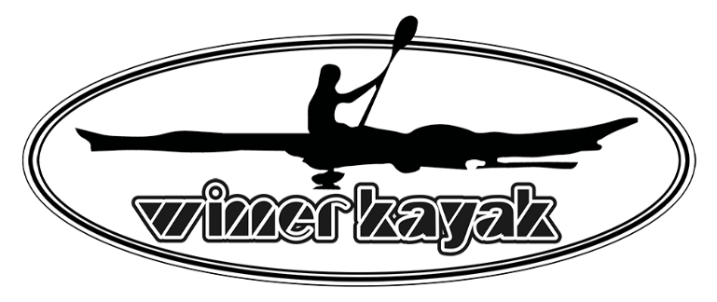
OnLine Links:
Kayak-ity-yak Inc. https://www.kayak-ity-yak.com/
Facebook: www.facebook.com/people/Kayak-ity-Yak-Inc
Instagram: www.instagram.com/kayak.ity.yak

“Kayak-ity-Yak Inc. (KIY) was established in 2011 and is the exclusive Canadian importer for the WINNER KAYAK brand of kayaks, SUPs, and kayak accessories.
Kayak-ity-Yak is also a Transport Canada licensed manufacturer of Sport Trailers recognized by the US Department of Transportation (DOT) for transporting outdoor gear such as canoes, kayaks, SUPs, small watercraft, personal watercraft, e-bikes, and cargo boxes.
Although KIY maintains its own retail showroom, we have always focused on wholesale distribution and we remain committed to expanding our growing authorized dealer base throughout Canada and the U.S.
Our business prides itself on working closely with small business owners on a one-on-one basis to ensure we are providing the highest level of dealer support. We maintain a dedicated Authorized Dealer Portal on our website that, among many other benefits, provides real-time access to on-hand inventory, marketing material such as image libraries, latest price lists, and ad copy.
Our 10,000sq ft distribution warehouse is centrally located north of Toronto and is within a day’s drive of southern Ontario, eastern Quebec, and much of the northeastern United States.” D. Courville, Severn, ON

