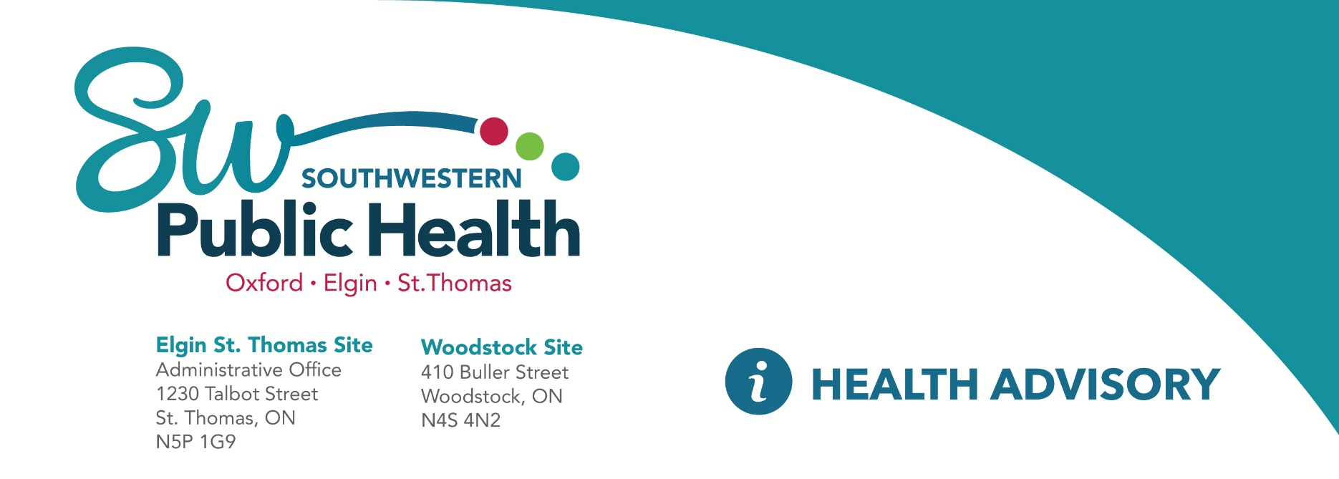

May 28, 2024

|  |  |  |  |  |  |
| --- | --- | --- | --- | --- | --- |
|  | | | | | |
| **From the Office of Dr. Ninh Tran, Medical Officer of Health, Southwestern Public Health** | | | | | |
|  |  |  | |  |  |
| **BOIL WATER ADVISORY** | | | | | |
| To Consumers of the Central Elgin Distribution System water supply:  The Medical Officer of Health, Dr. Ninh Tran, is advising that users of Central Elgin Distribution **System from Mackenzie Lane (formally Edith Street) to the West end of George Street**, bring water to a rolling boil for at least one minute prior to using it for domestic purposes e.g. drinking, making infant formula and juice, brushing teeth, washing raw foods and making ice.  The reason for the advisory is that the Medical Officer of Health has been advised that water sample results indicate the presence of bacteria in the water.    A “Boil Water FAQ” is available from the Southwestern Public Health Unit website at:  <https://www.swpublichealth.ca/en/community-health/boil-water-advisory-faq.aspx>      This advisory measure is in place until such time as bacteriological tests prove the water to be safe.  Please direct questions to our Environmental Health Department at 1-800-922-0096.   |  |  | | --- | --- | | **Dr. Ninh Tran Medical Officer of Health**  **Southwestern Public Health** | **Environmental Health Team**  **Southwestern Public Health**  **St Thomas Site**  **519-631-9900 Ext 1387 | 1-800-922-0096** | | | | | | |
|  | | | | | |
|  | | |  | | |